**[End of JSH: Reunion Show](https://www.nattarography.net/blog/19/8/2015/end-of-jsh-reunion-show)**

[August 02, 2015](https://www.nattarography.net/blog/19/8/2015/end-of-jsh-reunion-show)

Reunion show is finally over. I have uploaded this set of works to this website, which can be viewed under "Personal Works".

I am really thankful for the opportunity to exhibit this set of works, a byproduct of 6 months worth of planning. Talking to fellow JSH photographers has made me acknowledge that this set of works is by no means complete - I still have a lot more knowledge to acquire and so, with time, I hope that a more enlightened understanding will help me to make this set of works more complete.

I also hope to produce more sets of personal works, so keep a lookout for any projects that I will be embarking on!

*0 Likes*

*Share*

[**Reunion Show**](https://www.nattarography.net/blog/21/5/2015/reunion-show)

[May 21, 2015](https://www.nattarography.net/blog/21/5/2015/reunion-show)

My posts these days are rather sporadic, because I had been busy with school. Nevertheless, I haven't stopped shooting.

I've been preparing for the Junior Shooting Home - Reunion Show. To be honest, when I told the mentor, Joe, of what I planned to do, I wasn't so sure if I could pull the body of work off. Being stuck with lack of creativity, it took me many months of thinking before I could finally settle and draft out what I would like the final product to look like.

Mathematics isn't the most fascinating thing to put into pictures, but it's something that has radically changed the way I think and my outlook of life ever since I started college. Because it matters so much to me, I thought I'd try putting it into a series.

I've decided to go for a monochrome look. While I've yet to finish taking all the photos I need, here's a little teaser for now:

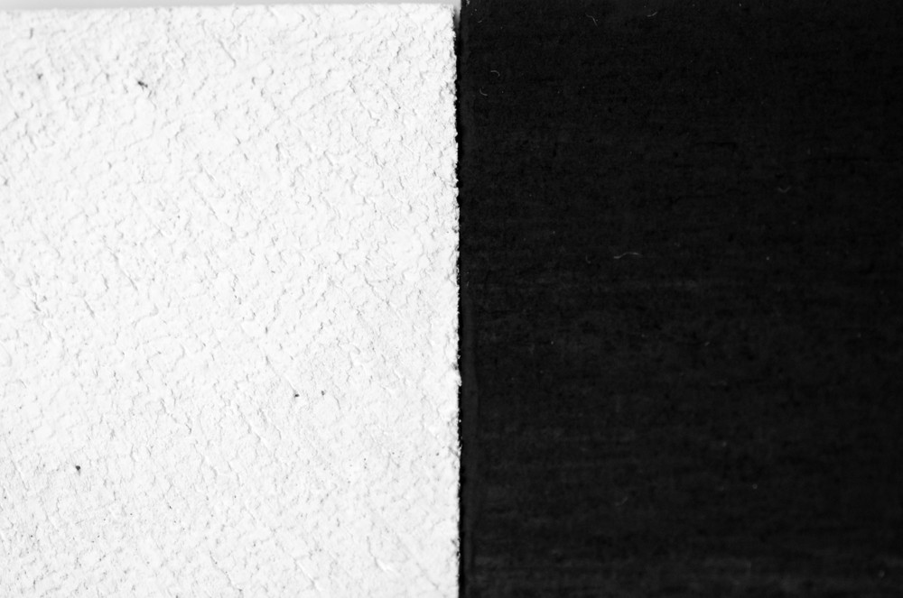

... although my teaser probably doesn't say much about what I intend to do, huh?

*0 Likes*

*Share*

[**Hoozuki no Reitetsu**](https://www.nattarography.net/blog/13/8/2014/hoozuki-no-reitetsu)

[December 03, 2014](https://www.nattarography.net/blog/13/8/2014/hoozuki-no-reitetsu)

I admit, this is a super backdated post. Shot this about 6 months ago.

Probably one of the first few shoots I attempted playing with smoke cakes. There's always a first time for everything - I used too much smoke cake and created a cloud too thick that we couldn't see much for awhile.

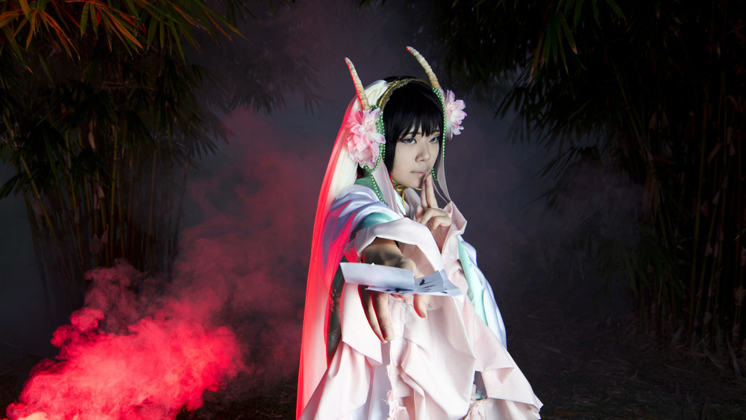

Hakutaku by Ning

Probably the only decent photo??

Smoke was whitish-grey, red color caused by putting a red-gelled flash behind it.

[**Extremely Controlled Lighting**](https://www.nattarography.net/blog/24/7/2014/extremely-controlled-lighting)

[July 24, 2014](https://www.nattarography.net/blog/24/7/2014/extremely-controlled-lighting)

I must say that shooting with Jencus was quite an eye-opener, and really cool in a sense.

I've never seen someone working with so many strobes and flashes at one go - to be precise, 3 strobes and 4-5 flashes. All of the flashes were precisely controlled with circular honey comb/coloured gels/narrow zooms/etc/etc. Maybe a potential candidate to be the next Joe McNally, if the number of flashes continue to increase over time haha.

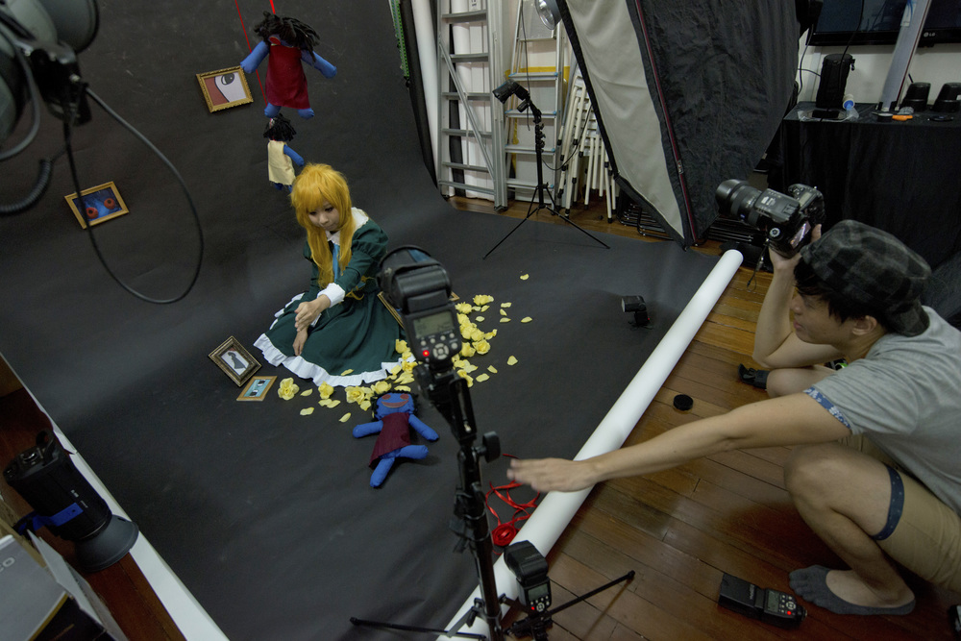

Of course, such an endeavour required much patience, especially when working on full manual, where every single additional flash requires time to adjust, and each photo took roughly 20-30 minutes to setup.

Tediousness aside, the pictures came out really nice. Light that lit up just all the right places and placing less emphasis on parts that didn't require the 'light attention'.

Which means less photoshopping on light related matters to focus on more beauty aspects. Get things right the first time, means less tediousness in post-processing.

Definitely a fun day.

[**Infrared Modded Camera**](https://www.nattarography.net/blog/7/7/2014/full-spectrum-camera)

[July 07, 2014](https://www.nattarography.net/blog/7/7/2014/full-spectrum-camera)

Managed to borrow an IR-modded D300 from a friend and thus, decided to play around with it. Since the White Balance was already preset, it wasn't as difficult to photoshop the colours around. I'm getting hooked onto this!

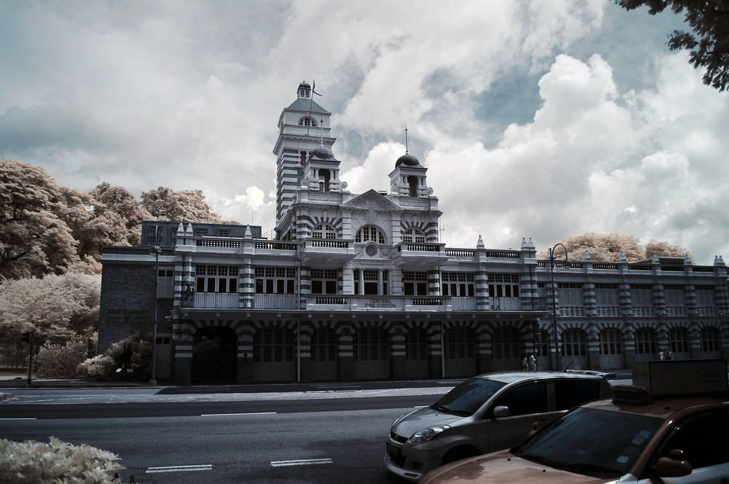

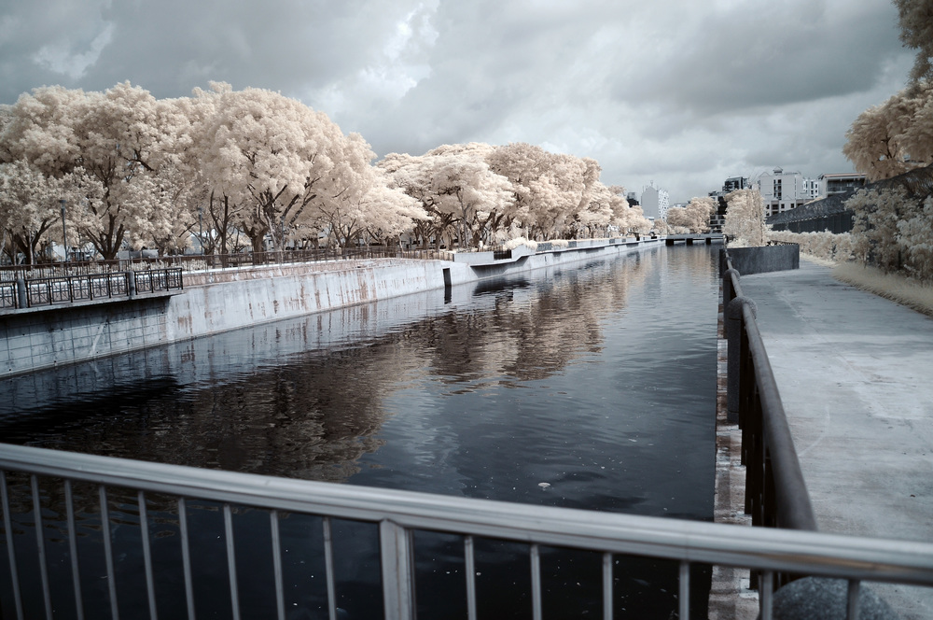

*1 Like*

*Share*

[**Tyersall House**](https://www.nattarography.net/blog/10/6/2014/tyersall-house)

[June 11, 2014](https://www.nattarography.net/blog/10/6/2014/tyersall-house)

It was a wild chance when I decided to jio my colleague to shoot the Tyersall house (more famously known as the Istana Woodneuk) with me. Wild chance because I didn't really know what I was doing.

To be honest, I wasn't really prepared for anything. Well, maybe I thought I was, but maybe I wasn't. I'm usually quite okay with my directions around urban areas, but forested areas are another thing altogther, coupled with the fact that we didn't exactly have some sort of map to follow... Lost my sense of direction as everything looked the same to me from every angle.

Furthermore, the steep slopes were slippery, with loose/muddy soil, dense vegetation and lose branches all over. I honestly think that my frequent runs at MacRitchie is much easier than this.

Well, I tried, but I guess I'm no good at this sort of thing - climbing slopes. Certainly I'm way too much of a city dweller, and also realising that our generation doesn't really know what exactly hardship is. Anyhow, it was quite the experience. We finally reached the place after much difficulty.

Seeing it made me awed, although I was really quite shagged to say much. Don't ask me what I was doing when I brought my 50mm along to shoot landscapes. I just thought I'd try something different, with, of course, disastrous results. But still, it was worth the hike up. A different side of Singapore rarely seen by most of us, and a beautiful one it was.

[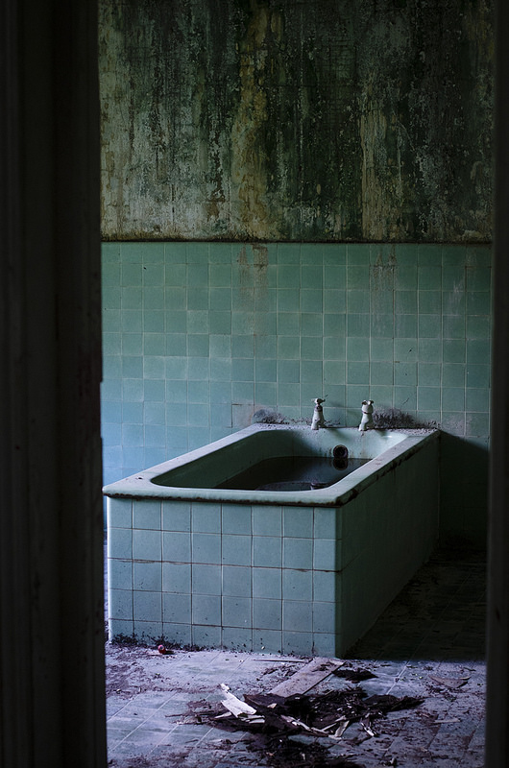](https://www.flickr.com/photos/nattaro13/14196563219)

[**SA CorpComms with Panda**](https://www.nattarography.net/blog/23/4/2014/sa-corpcomms-with-panda)

[May 02, 2014](https://www.nattarography.net/blog/23/4/2014/sa-corpcomms-with-panda)

3 days of super shag shooting with panda, being an assistant and "behind the scenes" shooter. But I did learn a lot from his lighting setup and the way he shoots in general.   
  
For one, it looked kinda complicated and random at first haha. But I started to see the pattern of where he was placing the lights, especially in the classrooms. And making good use of the fact that we had white classroom ceilings and walls. Bouncing light all over the place, haha.   
And of course, finally seeing the Lumia Mini Boom Arm in action.

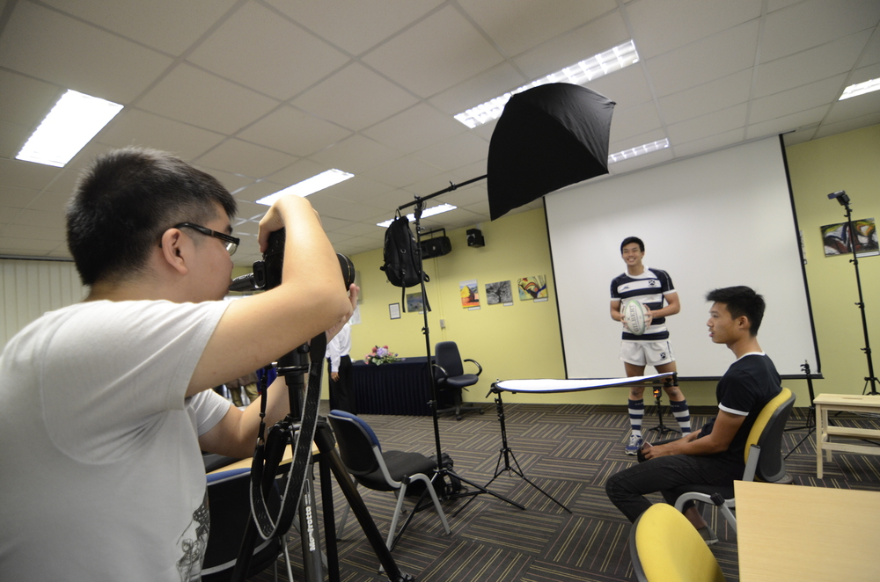

Lumia Mini Boom Arm!

Secondly, the way he directs his subject just makes me think a lot as well. He has many clear, easy to follow instructions and ideas to make a posed look look really natural and all. Sometimes the subjects may look too stiff when asked to pose. Solution to the problem?

"Close your eyes, on the count of three, pop them open and give me a wide smile!"  
Sounds cheesy but works 80% of the time :)

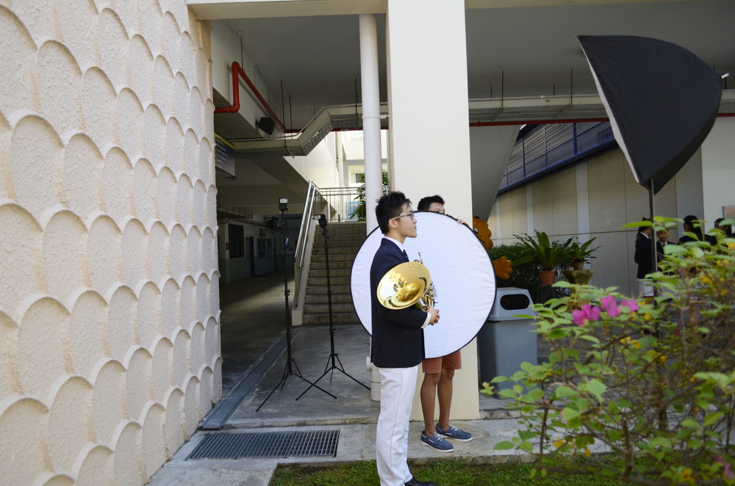

Thirdly, how he communicates with the people who want the photos, in this case, the coordinator. Much poise really. Making sure everything's clear and what's needed is done.

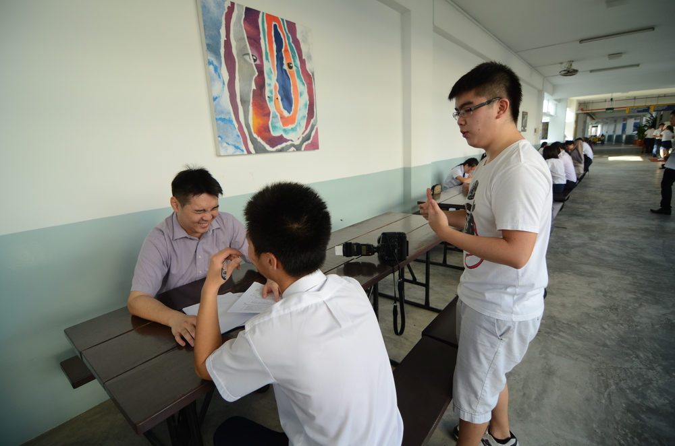

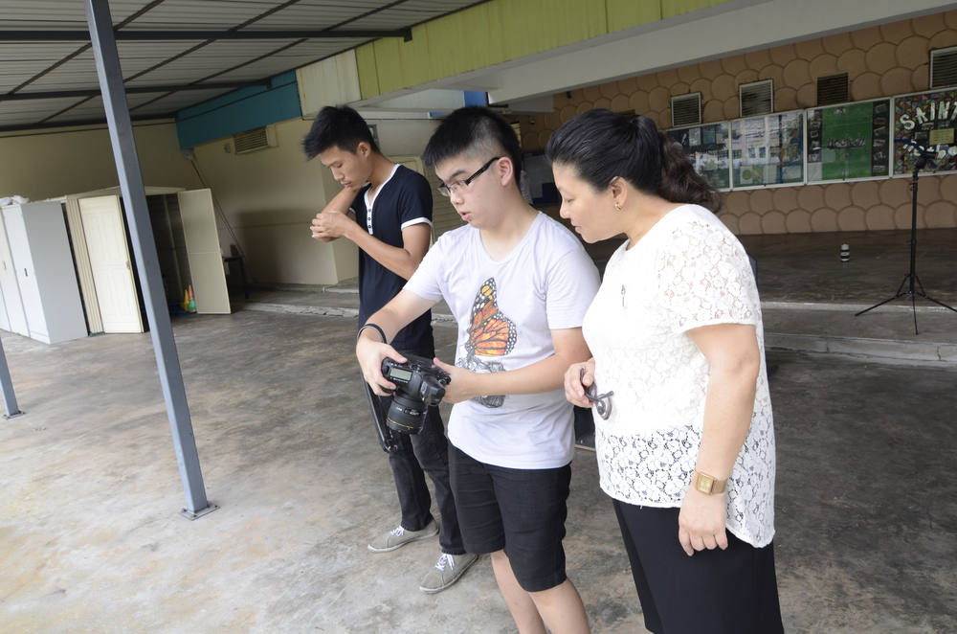

And also, his speedy-ness yet organised way of shooting (probably?)

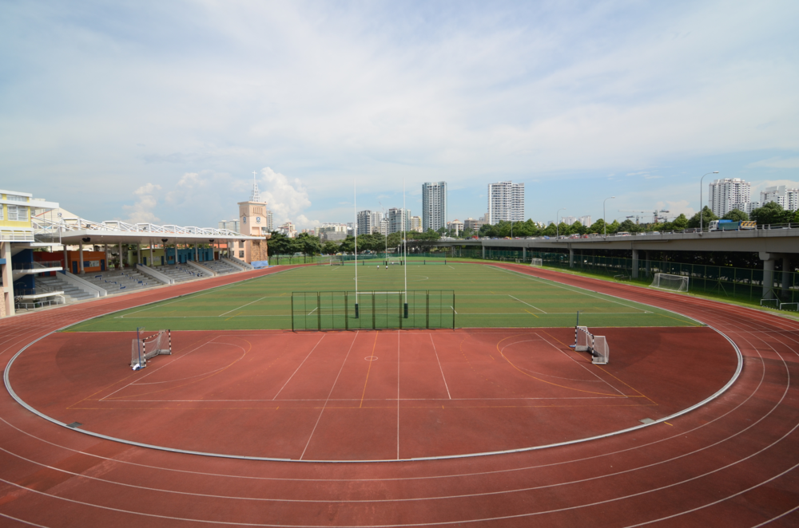

And of course, not forgetting one key takeaway, being able to shoot the school field wide open. Really like this shot, although the straight lines aren't straight.

Lastly, yay for free food!

[**Godox 360**](https://www.nattarography.net/blog/30/3/2014/godox-360)

[March 30, 2014](https://www.nattarography.net/blog/30/3/2014/godox-360)

Setup for the day:

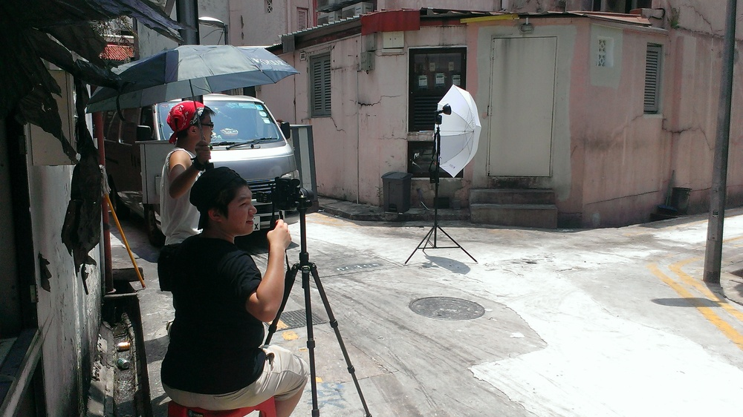

I have to admit, as a long time user of the Yongnuo 560 flash, I was skeptical that a Godox flash (in this case a Godox 360) can make a lot of difference to a photo in broad daylight. Afterall, the yongnuo manual flash is both cheap and good, and has served me well. The Godox on the otherhand, was ridiculously expensive, about $600 more than the yongnuo!

Lessons Learnt:

1. That difference of a few stops of guide number makes a HUGE difference. Godox 180: GN60 @ 28mm, Godox 360: GN80 @ 28mm, YN-560 : GN58 @ 105mm. One Godox can fight the sun whereas the YN-560 alone couldn't. You might probably need about 9-13 yongnuos to fight the sun.

2. The Godox leaves a much nicer 'catchlight' in the eyes and spectacles. When the Godox was tested against someone wearing spectacles, it left a circular and smaller flare on the spectacles, wheres the YN-560 left a squarish and large flare on the spectacles.

3. The Godox is a horrible optical slave. The YN-560 on the otherhand, was a good optical slave, and thus used as the secondary flash for purposes such as rim lighting/side lighting/etc.

4. The Godox is probably better value for money than a portable manual strobe given its guide number and slightly smaller size.

5. The Godox, when used with its counterpart Godox trigger, allows you to do hyper-sync. First time I've heard of this term and how different it is compared to high-speed sync. Totally blew me off my feet. Technology is so awesome.

Overall, it was great being able to watch my friend,Archie, shoot. As someone who has always looked up to his works, it's nice being able to work alongside such a great photographer, even if it's just saikang work. Fun day really.

Hope I'll get an opportunity to see more local cosplay photogs in action in the near future. It's really fun learning from them and watching them shoot. :)

Looks like many of us got poisoned by the Godox after this shoot!

*1 Like*

*Share*

[**CPLs & Mt Faber Park**](https://www.nattarography.net/blog/21/3/2014/cpls-mt-faber-park)

[March 21, 2014](https://www.nattarography.net/blog/21/3/2014/cpls-mt-faber-park)

It all started from a chat with my colleague, Eric, about CPLs, as he was considering whether or not to buy a circular polariser. I've no idea how, but the conversation eventually morphed into a "If I buy a B+W CPL, can we ask Jon to sponsor the Chromage CPL in return for a review?"

The outcome: we can borrow the Chromage CPL, but we still have to do a review.

Anyway, we decided to head down to Harbourfront to shoot cranes as well as test out all the different CPLs (Chromage, B+W mrc slim, and B+W MRC KSM Nano) in our shop, as well as one which I currently have, the Tian Ya CPL. It was a pretty sway day for us, as the process of testing the CPLs resulted in us breaking a wired remote shutter release cable and the Tian Ya CPL. To top it off, we couldn't find a good vantage point for shooting the cranes despite shooting since morning.

In the end, we climbed Mt Faber Park to the top to take some pictures (no decent results too) in order to play around with the ND filters and Cokin GNDs which my friend had lent to me the weekend before. The photo below was taken with a Cokin GND 8 to darken the skies a little. It was still a pretty good view despite the trees blocking Keppel Terminal and the view of Pasir Panjang.

Now, back to work on the CPL review.

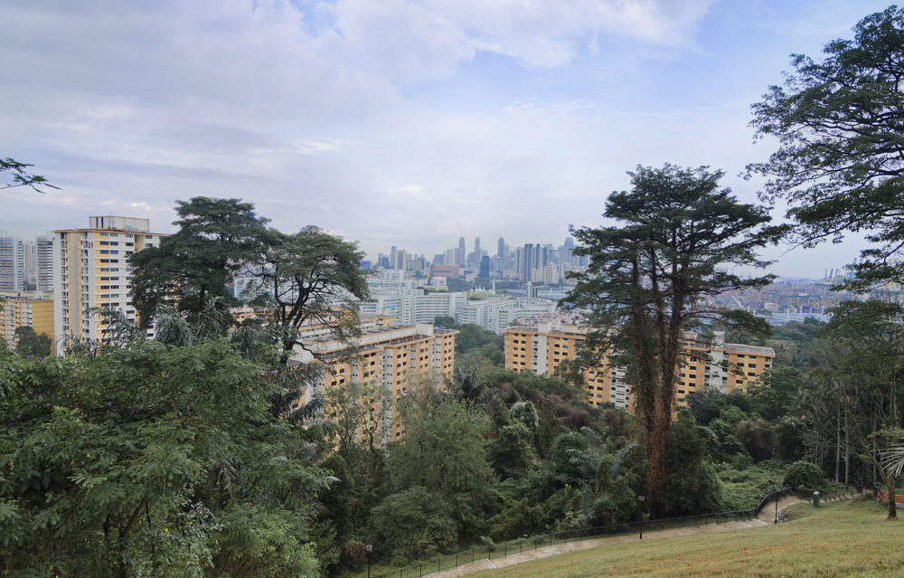

*0 Likes*

*Share*

[**Back to Basics**](https://www.nattarography.net/blog/10/3/2014/back-to-basics)

[March 10, 2014](https://www.nattarography.net/blog/10/3/2014/back-to-basics)

For all the things I've shot as of late, it seems puzzling that I'd start from scratch all over again. Not for flashes, but for strobes, although it's still the same thing - controlling light. But I've always believed that having a strong grounding in the basics will greatly help for more advanced techniques. I've done the exact same thing for programming. I'm pretty well-versed in Python - functions, recursion, loops, selection control structures, classes, pointers, so on and so forth. Given that programming concepts are universal, I should have no problem jumping straight to pointers when I started doing C. But no, I chose to re-start from basics, even doing boring stuff like "printf("Hello World!")" or "int a = 2". And I'm glad that I did so, because C syntax can be quite troublesome, and if you don't know basics, de-bugging a long and difficult programme can get pretty difficult even if an error can be caused by just missing out a {}.

So here I am, re-learning studio shooting techniques. It is also my first attempt at using studio strobes, and also the first time I'm meeting my colleague over at the Geylang office side, Aaron. It was really fun shooting Monica and Ryan with him and Zhi Lin. Thank you so much for allowing me to come over :)

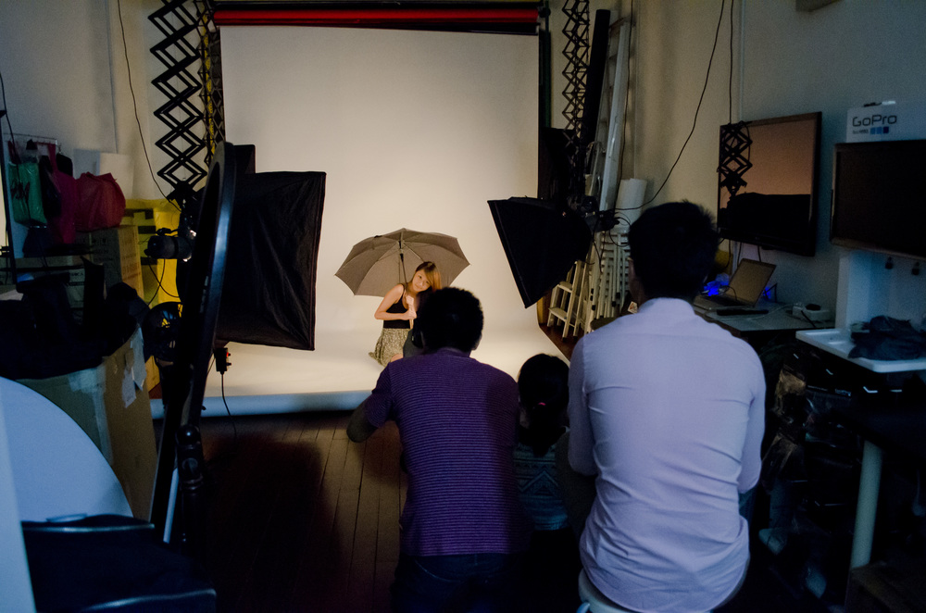

Shooting in progress!

In this order:

Split lighting, Loop Lighting, Short Lighting, Butterfly Lighting

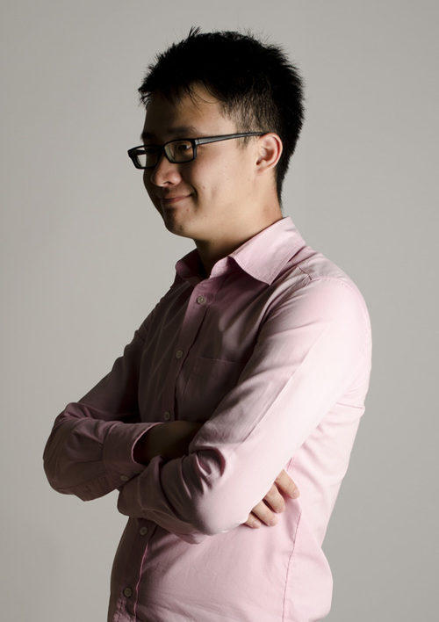

After that, we got to the exciting part - the pair shots. Playing around with all kinds of lighting and even trying to make the dry ice flow out properly. The dry ice attempt failed so terribly and Aaron kept boiling hot water to try to make it flow out more. Anyhow, the shots were still pretty decent, so I guess we can play with dry ice again next time.

